1.Created a test table

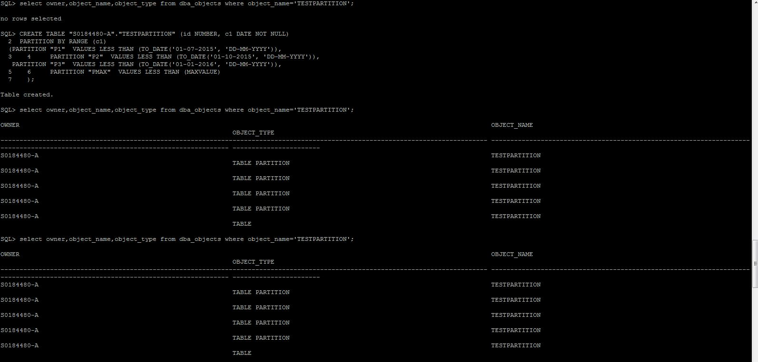

2.Insert values into the table.

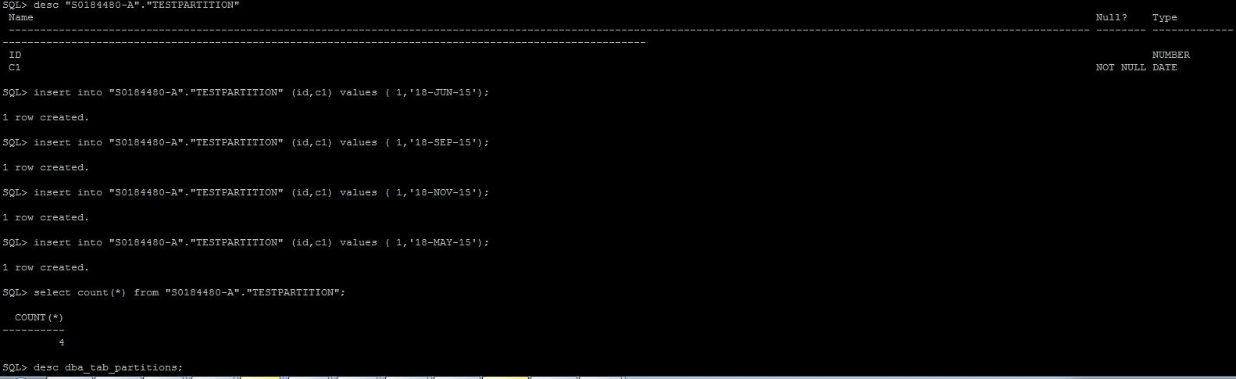

3.Selecting max partition date of the table.

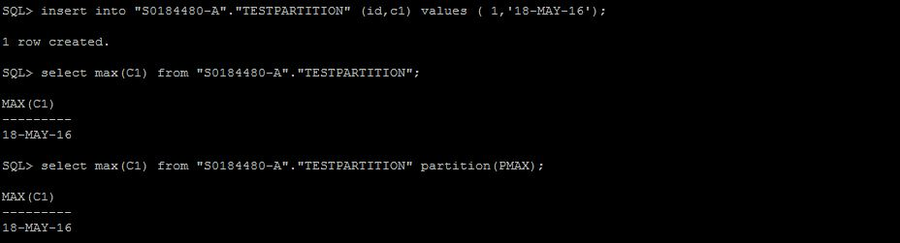

4. Automatically prints the max partition name and last date to be partitioned.

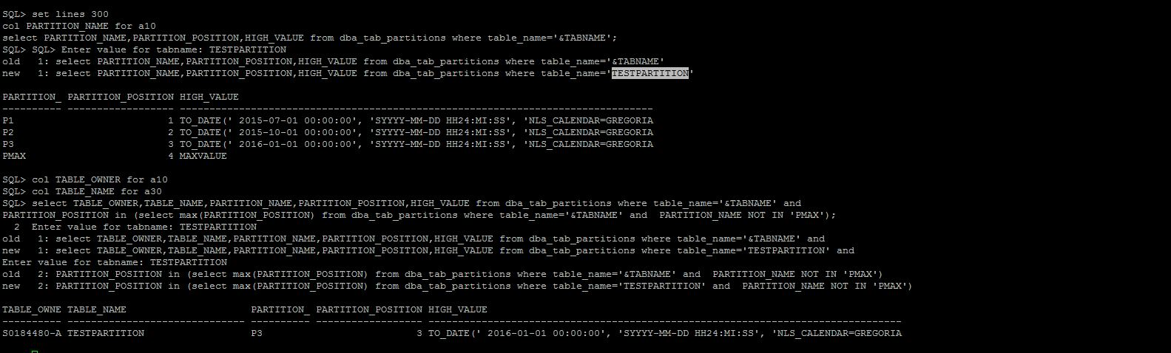

5. Automatically splits PMAX by taking tablename and owner as input.

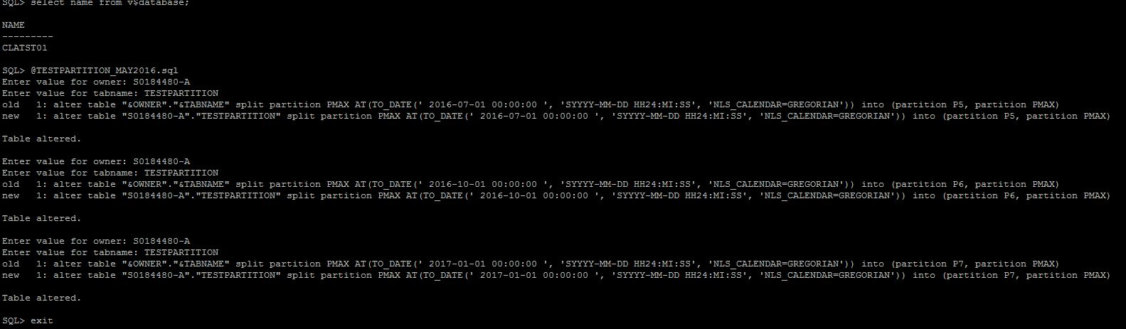

6. Partition P5 now holds the max partition date of the table.

